# What is Recombee?

Recombee is an easy to use, recommender system that uses machine learning to provide companies with suggestions based on the datasets that they provide. It saves companies time and money from creating their or recommendation software. It is ‘The most advanced engine tailored by data scientists’ (Digital n.d).

# Why use Recombee?

* It is a real time recommendation as a service. Its API returns recommendations after user’s action to the website or app in less than 200ms.
* Service is provided no matter how much traffic there is on the website/server.
* It is widely used by companies
* Easy to set rules using a simple query language

(Digital n.d)

# How to use Recombee?

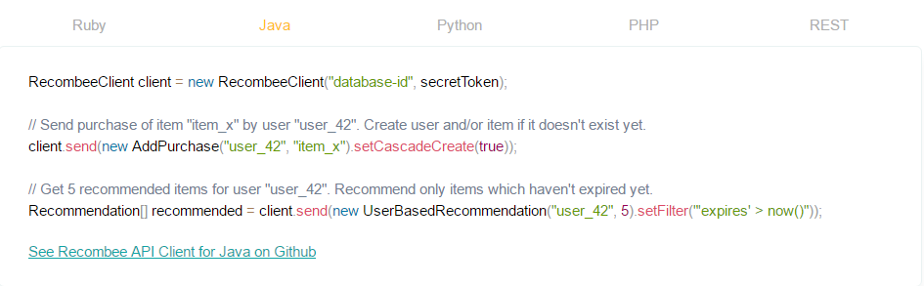  
**(Digital n.d)**

The API client for java can be downloaded from GitHub.

# Functionality of the free user service

For free, we will be able to use the full API and have up to 99,999 recommendations which is more than enough for our start-up usage. In the case of the project expanding and turning the app into a business idea, Recombee charges $100 a month for ‘nearly unlimited number of recommendation requests’ (Digital n.d) **(Digital n.d)**

# Useful Links –

Introduction to Recombee in less than 10 minutes - <https://www.youtube.com/watch?v=C4nGZMao1ZY>

Useful information about Recombee - <https://www.programmableweb.com/api/recombee>

GitHub link to the full Java API - <https://github.com/Recombee/java-api-client>

# Bibliography

Digital, E. (n.d.) *Recommender as a service* [online] available from <https://www.recombee.com/> [18 February 2017]